20MCA136 – NETWORKING & SYSTEM ADMINISTRATION LAB Dept. of Computer Applications

# NETWORKING & SYSTEM ADMINISTRATION LAB

**Name: MELBIN M P**

**Roll No: 19**

**Batch: S2 RMCA B Date: 12-05-22**

**Experiment No : 21 Aim**

Write a shell script to find the average of numbers entered in command line with limit.

# Procedure:

#!/bin/bash

echo "Enter the limit" read n

i=1 sum=0

echo "Enter the numbers:" while [ $i -le $n ]

do

read num sum=$((sum + num)) i=$((i +1))

done

avg=$(echo $sum / $n | bc -l) echo $avg

# Output:

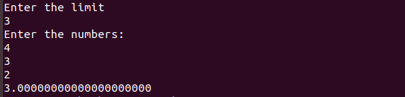

Amal Jyothi College of Engineering, Kanjirappally